**EXP 25: Create and Configure a New VM Image in Azure (Demonstrating DaaS)**

**Aim:**

To create and configure a virtual machine (VM) image on Microsoft Azure and use it to deploy a database service, demonstrating **Database as a Service (DBaaS)**.

**Procedure (Step-by-Step)**

**Step 1: Log in to Azure Portal**

1. Go to https://portal.azure.com
2. Sign in with your Azure account.

**Step 2: Create a Resource Group**

1. Search for **Resource Groups** → Click **Create**.
2. Fill details:
   * **Resource Group Name:** VM_DBaaS_RG
   * **Region:** Nearest available region
3. Click **Review + Create** → **Create**.

**Step 3: Create a Virtual Machine**

1. Search for **Virtual Machines** → Click **Create → Azure Virtual Machine**.
2. Fill the **Basics** tab:
   * **Subscription:** Azure for Students / Free Tier
   * **Resource Group:** VM_DBaaS_RG
   * **VM Name:** DBServerVM
   * **Region:** Same as resource group
   * **Image:** Choose an OS (e.g., **Ubuntu 22.04 LTS** or **Windows Server 2022**)
   * **Size:** Select minimum CPU/RAM (e.g., B1s – 1 vCPU, 1 GB RAM)
   * **Username/Password:** Enter admin credentials
3. **Disks:** Keep default (SSD)
4. **Networking:** Allow public inbound ports → **SSH (Linux)** or **RDP (Windows)**
5. Click **Review + Create** → **Create**.

**Step 4: Connect to the Virtual Machine**

* For **Linux VM** → Use SSH:

ssh username@PublicIP

* For **Windows VM** → Use **RDP client** with VM IP address.

**Step 5: Install Database Server**

* **Linux VM (Example MySQL):**

sudo apt update

sudo apt install mysql-server -y

sudo systemctl start mysql

sudo systemctl enable mysql

* **Windows VM (Example SQL Server Express):**
  + Download SQL Server Express installer and install.
  + Configure authentication mode and admin credentials.

**Step 6: Configure Database**

* Login to the database and create a sample database

**Step 7: Create a VM Image**

1. Stop the VM from the Azure portal (**Stop → Deallocate**).
2. Navigate to the VM → **Capture**.
3. Fill the details:
   * **Image Name:** DBServerVMImage
   * **Resource Group:** Choose same or new
   * **Automatically delete VM after creating image:** Optional
4. Click **Create**.
5. Now you have a reusable **VM Image** with the database pre-installed.

**Step 8: Deploy a New VM from the Image**

1. Go to **Images → Select DBServerVMImage → Create VM**
2. Fill the same details as before.
3. The new VM will have **database server ready to use** → Demonstrates **DBaaS**.

**Step 9: Verification**

* Connect to the new VM → Open database → Run queries to check tables and data.

**Output:**

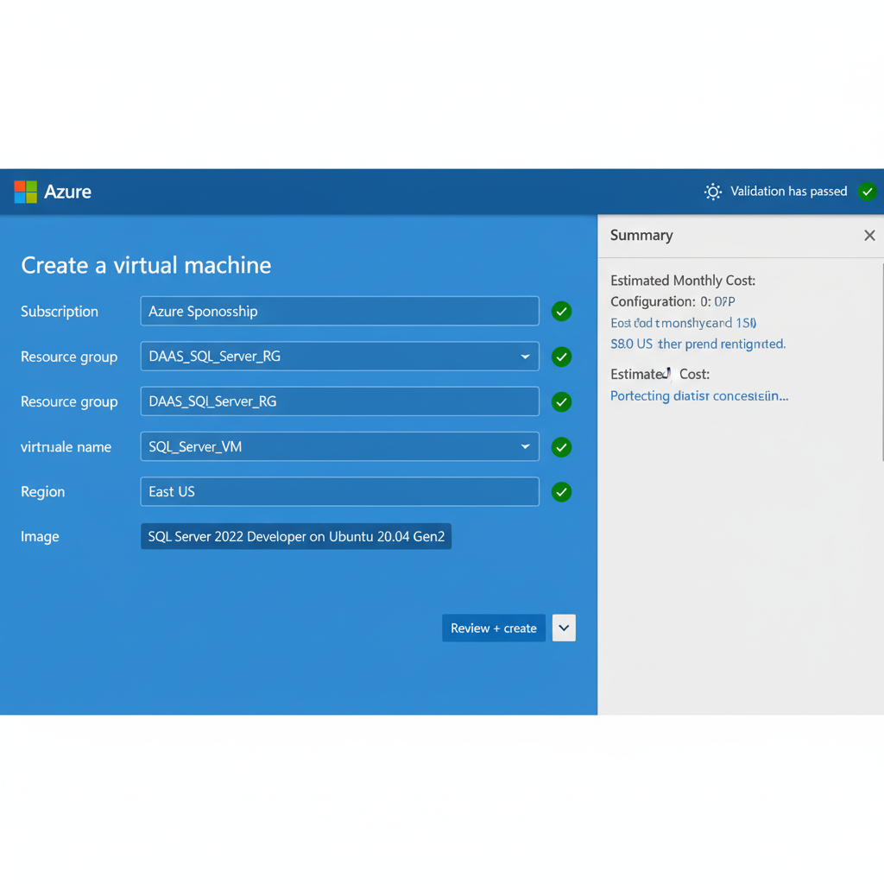

**Result:**

A virtual machine image with a configured database server was successfully created in Azure. Using this image, new VMs can be deployed quickly with the database service ready, demonstrating **DBaaS functionality**.